Enrolment Form 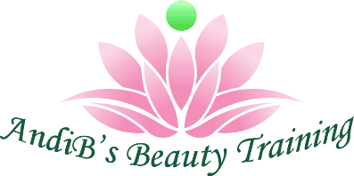

PERSONAL DETAILS

First Name: | Surname: | Date of Birth:
Home address: | Salon address (if applicable) | Email address:
Home phone: | Salon phone: | Mobile phone:

Do you have any experience in the beauty industry?

If yes, what experience have you gained?

COURSE INFORMATION

Name of course(s) you are applying for Cost of course
1.

2.

3.

4.

Discount (if applicable) -10%

TOTAL | £

Where would you prefer to take your course(s)?

Please fill the appropriate box. Please note, we travel 20 miles radius from Horsham only.
In our training room |  | 14 Warnham road, Broadbridge Heath/Horsham West Sussex RH12 3JZ
In your salon? – Fee applies |  | Name of salon:  Address of salon:  Post code:  Contact name:  Contact number:
In your home? – Fee applies |  | House name or number:  Address:  Post code:  Contact name:  Contact number:

Do you have any special requests relating to the course?
If yes, please give details.

Course manuals

We send the course manual(s) via email when the deposit has been paid. | FREE
Manuals in hard copy can be ordered at a price of £10 each or £8 for 2 or more.  Free postage. | Yes, I would like a hard copy  No, thank you

Before you enrol on any AndiB’s Beauty Training course, it is your responsibility to check with your potential/existing insurance provider and/or county council to ensure you are able to gain your public liability, business insurance and any council license requirements. AndiB’s Beauty Training and ABT cannot be held responsible for local council requirements. Please read our T&C and Cancellation Policy https://www.andibsbeautytraining.com/
PLEASE SEND THIS APPLICATION FORM TO andibsbeautytraining@gmail.com

Signed________________________ Date____________

